PDC Lab 8
Advait Deochakke
20BCE1143

Sample Hello World

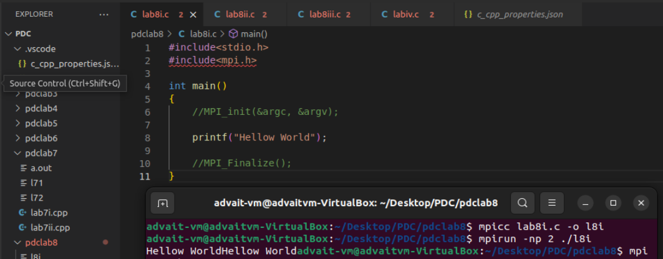
Code:
#include<stdio.h>
#include<mpi.h>

int main()
{
//MPI_init(&argc, &argv);

printf("Hellow World");

//MPI_Finalize();
}

Prink rank, world size and processor name

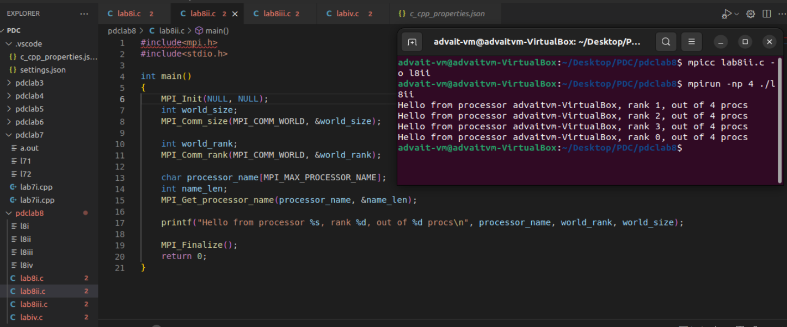
Code:
#include<mpi.h>
#include<stdio.h>

int main()
{
MPI_Init(NULL, NULL);
int world_size;
MPI_Comm_size(MPI_COMM_WORLD, &world_size);

int world_rank;
MPI_Comm_rank(MPI_COMM_WORLD, &world_rank);

char processor_name[MPI_MAX_PROCESSOR_NAME];
int name_len;
MPI_Get_processor_name(processor_name, &name_len);

printf("Hello from processor %s, rank %d, out of %d procs\n", processor_name, world_rank, world_size);

MPI_Finalize();
return 0;
}

Master prints "I am Master", Worker prints "I am worker"

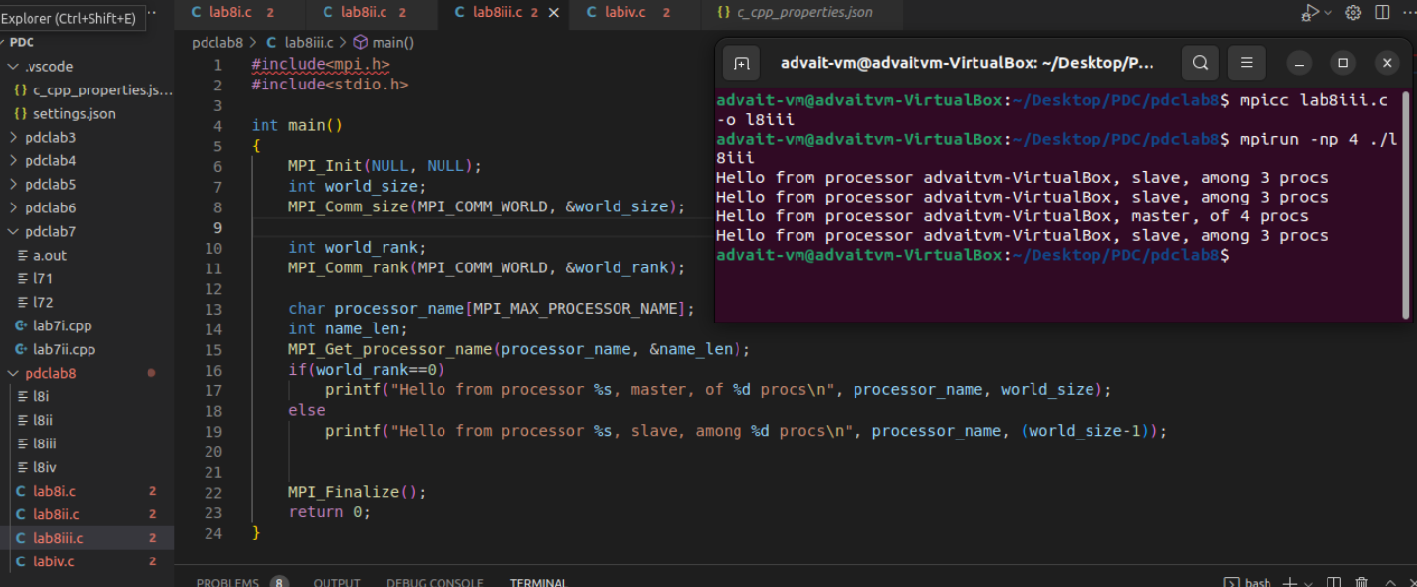
Code:
#include<mpi.h>
#include<stdio.h>

int main()
{
MPI_Init(NULL, NULL);
int world_size;
MPI_Comm_size(MPI_COMM_WORLD, &world_size);

int world_rank;
MPI_Comm_rank(MPI_COMM_WORLD, &world_rank);

char processor_name[MPI_MAX_PROCESSOR_NAME];
int name_len;
MPI_Get_processor_name(processor_name, &name_len);
if(world_rank==0)
printf("Hello from processor %s, master, of %d procs\n", processor_name, world_size);
else
printf("Hello from processor %s, slave, among %d procs\n", processor_name, (world_size-1));

MPI_Finalize();
return 0;
}

Master generates 1/2,1/4,1/8,1/16...1/n; Worker generates 2,4,8,16...n
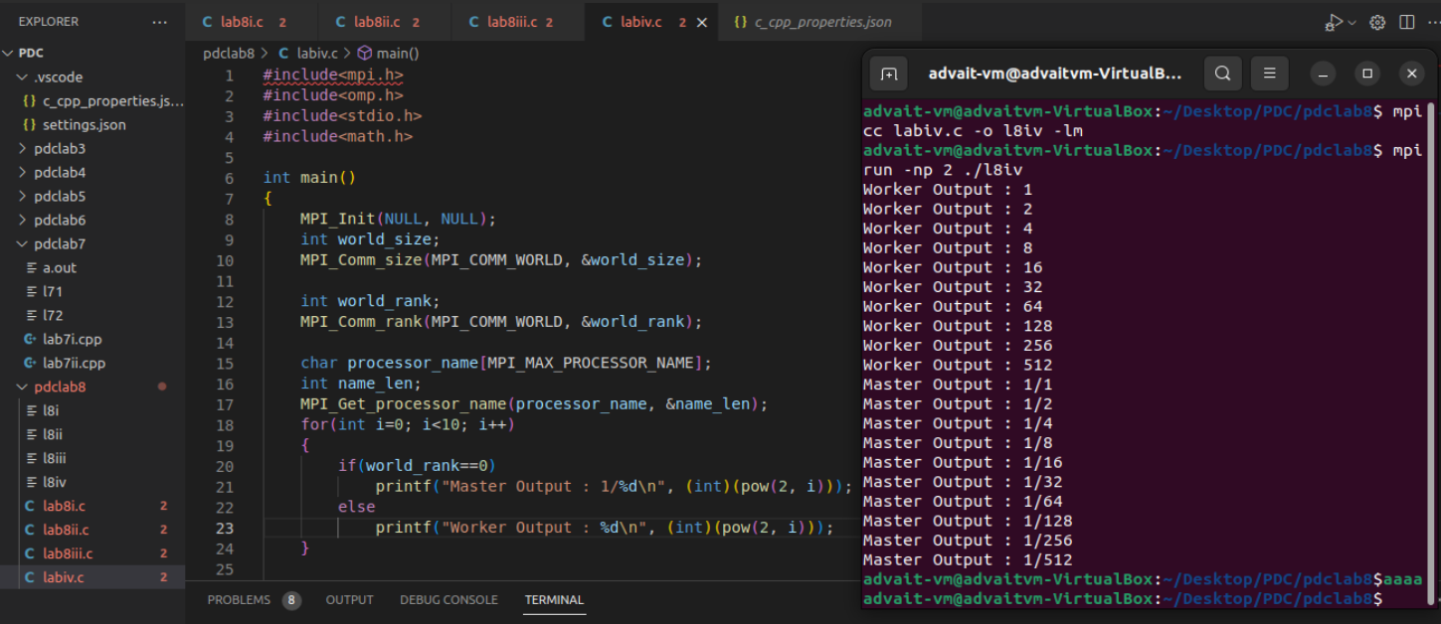
Code:
#include<mpi.h>
#include<omp.h>
#include<stdio.h>
#include<math.h>

int main()
{
MPI_Init(NULL, NULL);
int world_size;
MPI_Comm_size(MPI_COMM_WORLD, &world_size);

int world_rank;
MPI_Comm_rank(MPI_COMM_WORLD, &world_rank);

char processor_name[MPI_MAX_PROCESSOR_NAME];
int name_len;
MPI_Get_processor_name(processor_name, &name_len);
for(int i=0; i<10; i++)
{
if(world_rank==0)
printf("Master Output : 1/%d\n", (int)(pow(2, i)));
else
printf("Worker Output : %d\n", (int)(pow(2, i)));
}

MPI_Finalize();
return 0;
}

-------------------------------------------------------------------------------------------------------

